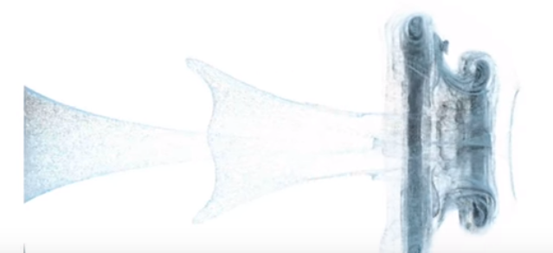Final Project Proposal   
CS 6610-001 Spring 2019

# Schrödinger's Smoke

Given that all of the interactive models we have done in our projects thus far this semester have essentially been static (in the sense there was never a physical change to the pot as a result of time), I wanted to try to simulate a physical phenomenon. Reading over the SIGGRAPH papers from 2016 I found an article on [Schrödinger's Smoke](http://multires.caltech.edu/pubs/SchrodingersSmoke.pdf) which peaked my interest, and it was based in part off of a similar article published in SIGGRAPH 2005 which can be found [here](http://dx.doi.org/10.1145/1073368.1073380).

The 2016 paper entitled “Schrödinger's Smoke” apparently presented a newer method for “the purely Eulerian simulation of incompressible fluids” and was prominent enough to be selected for SIGGRAPH. I plan in my project to implement the same. My high-level goal is simply to implement the smoke simulations in enough resolution and quick enough to be convincible, and barring my inability to do that, extend it to the method described in the paper.

I anticipate my final results to look (loosely) like the following:

